**Name – Ayush Mondal**

**Sec – A , B.Tech (CSE)**

**Subject – OS**

**Registration no – 200010170880**

**Enrollment no – 2011200001017**

1.Write a shell script program to emulate the calculator function. Take two numbers from user. Take a choice from user [1-4]. If the choice is 1, then add the numbers and display the result. If the choice is 2, then subtract the numbers and display the result.If 3, then multiply. If 4 then divide.

echo "Enter Two numbers : "

read a

read b

echo "Enter Choice :"

echo "1. Addition"

echo "2. Subtraction"

echo "3. Multiplication"

echo "4. Division"

read choice

if [ $choice -eq 1 ]

then

result=`expr $a + $b | bc`

echo "Result :"$result

elif [ $choice -eq 2 ]

then

result=`expr $a - $b | bc`

echo "Result :"$result

elif [ $choice -eq 3 ]

then

result=`expr $a \* $b | bc`

echo "Result :"$result

elif [ $choice -eq 4 ]

then

result=`expr "scale=2; $a / $b" | bc`

echo "Result :"$result

else

echo Invalid choice...

fi

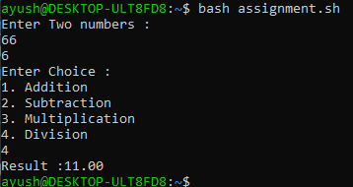  
2 .Write a shell script program to check whether a number is positive, negative or equal to zero and print the output.

echo "Enter a number : "

read num

if((num < 0))

then

echo "$num is a negetive number"

fi

if((num == 0))

then

echo "$num is equal to zero"

fi

if((num > 0))

then

echo "$num is a positive number"

fi

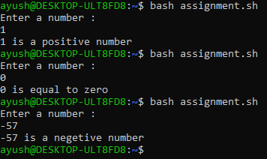

3 . Write a shell script to generate n Fibonacci numbers. Where n is user input.

for((i=1;i<101; i++))

do

if((i % 3 == 0))

then

echo $i

fi

done

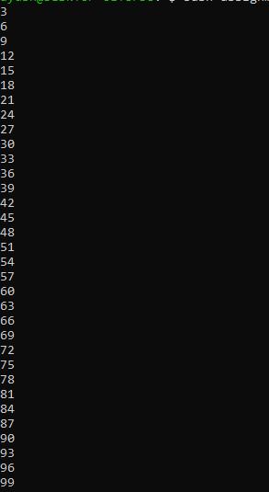

4. Write a shell scripts to calculate the factorial of an integer no.

echo "Enter the number to find the factorial"

read num

fact=1

for ((i=1;i<=num;i++))

do

fact=$((fact * i ))

done

echo "The factorial of $num is :"$fact

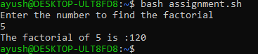

5. Write a shell scripts that will find the GCD of two given numbers .

echo "Enter the two number to Find GCD"

echo "Enter the 1st number:"

read num1

echo "Enter the 2nd number:"

read num2

while [ $num2 -ne 0 ]

do

rem=$(( num1%num2 )) num1=$num2 num2=$rem

done

echo "The GCD of two numbers is:"$num1

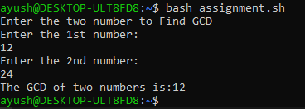

6. Write a shell script to generate n Fibonacci numbers. Where n is user input.

echo "How many number of terms to be generated ?"

read n

x=0

y=1

i=2

echo "Fibonacci Series up to $n terms :"

echo "$x" echo "$y"

while [ $i -lt $n ]

do

i=`expr $i + 1 `

z=`expr $x + $y `

echo "$z" x=$y y=$z

done

r=$n

echo "$r

